Taejay Lee Bio_NYFA

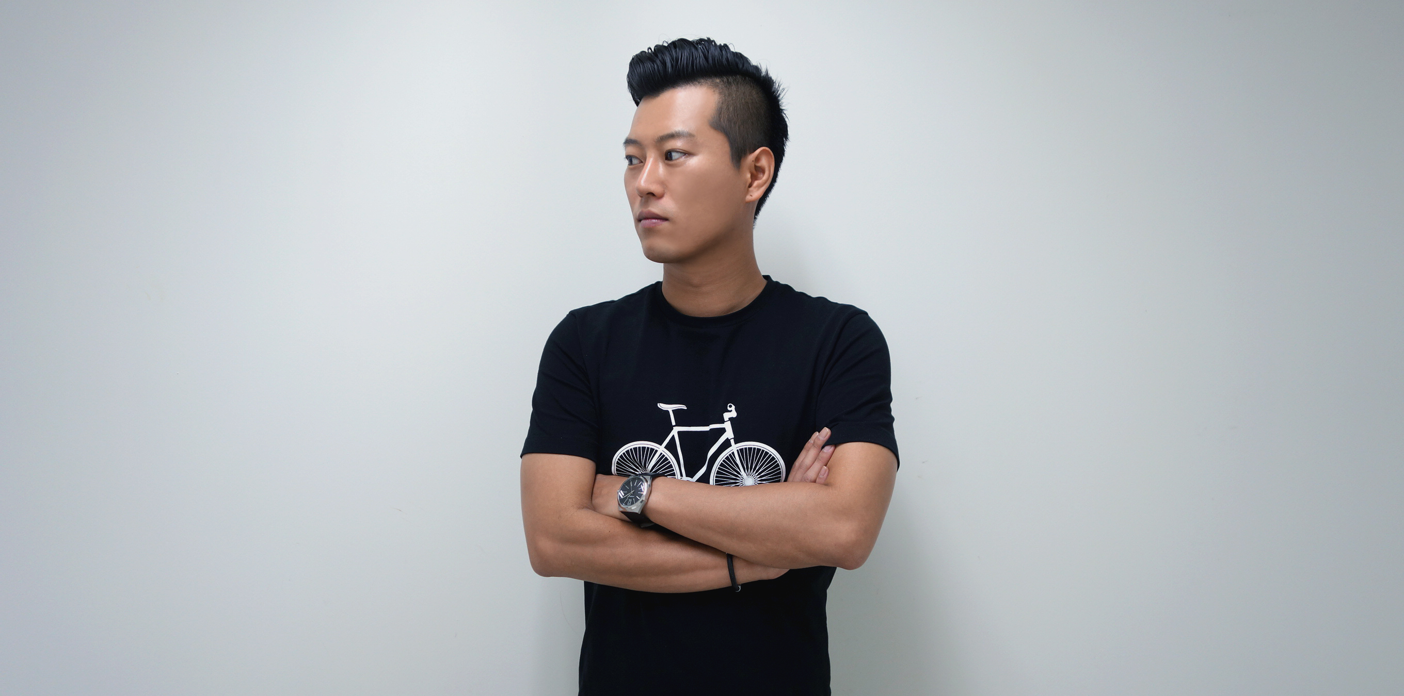

Taejay Lee

Creative Director

[leetaejay@gmail.com](mailto:leetaejay@gmail.com)

+34 683 475 597

Taejay is a digital native who got his professional start in the gaming industry in Korea, his homeland. During his time with the game maker Min Communications, he helped commercialising 3D MMORPG game globally and launched an international game tournament show across 8 countries.

His creative wanderlust then took him to a variety of places such as Bangkok, London, and Amsterdam at ­­shops like FCB, Saatchi & Saatchi, Nomads, and THEY where he honed his skills in advertising that won client’s hearts and awards.

He has conducted an orchestra with animals, made people to taste a cracker with ears, turned every gamer into Leo Messi, crafted an art with a vacuum cleaner, and built a hoverboard racing circuit at the F1 Monaco

GP along the way.

At home TJ dedicates himself to cooking Korean BBQ for his Spanish wife and Scottish Terrier, and nurturing a love for Kimchi in anyone who shows an interest on fermented spicy food.